Chris Rozelle
Professor Mayeux
ENG 1400 Section 5: Composition
13 September 2012
Unemployment: Conflicting Perspectives
What did the soldier say to the graduate? According to Jim Borgman of the Cincinnati Enquirer in 2003, the soldier proffers insight on unemployment to a dimwitted scholar. The soldier focuses on a message of conflict regarding a rise in unemployment over only four months of that year (Gongloff). The Enquirer’s readers are typically middle class adults interested in political and economic opinions printed in a newspaper. However, Borgman’s cartoon is constructed in a way that is effective for the target audience because the readers could relate to the moral of the cartoon.
The American audience directly related to the theme of the cartoon because the theme presented is logical. The youth were facing limited long-term career options based on the rise in national unemployment rates. Borgman utilizes the characters of a graduated scholar and a trained soldier to depict the common life choices that many young adults faced in 2003. According to Boston.com, in the last decade, when there was a ten percent decrease in employment, the military experienced a five percent recruitment growth (Bender). The rejection of a formal college education is completely understandable with a guaranteed allowance, debt forgiveness, convenient Reserve Officers' Training Corps (ROTC) programs, and high job security offered by the military. In fact, the Army alone recruited over 101,000 men and women to join the active and reserved armies in the year 2003 (“Support Army Recruiting”). From the evidence of this record-breaking statistic, it can be assumed that a large majority of the American population can in some way relate to the choices being made by young men and women. Whether a family member, friend, or acquaintance, the readers of the Enquirer could relate to the depiction of choice faced by the youth in 2003.
Using the vernacular of the target audience, the diction and perspective of the cartoon boosted the cartoon’s affect. Interestingly enough, the soldier gives the only remark written into the cartoon, a remark typical of the highly educated as opposed to a man of war. Borgman crafted the soldier’s blunt statement to create relational insight to the choice of college versus military. For example, the soldier uses the words “figure” and “easier”, implying that he has qualms about his career but not necessarily about his career decision. Another significant word is “find”. Borgman could have easily utilized the phrase, “going to”. However the former word choice implies a sense of obligation as opposed to a confident decision. The words used by the soldier gives the audience a chance to sympathize with the youth making these difficult decisions.
In regard to purpose, the confused characters in the cartoon effectively cause its audience to relate to the idea presented in the cartoon. Both men carry a rolled up piece of paper,the symbol for their purpose and future steps. However, there is a stark difference found in how each character holds the roll. The soldier appears ready to move, ready to follow the marching orders assumed to be on the paper. Interestingly enough, the scholar holds his roll as a baby would hold a fork: he sees no value in the roll. Therefore, to the target audience, the posture of the scholar reflects an image of a small, lost child. Since the cartoon invokes a sense of sympathy for the characters, the overarching theme of the comic is described as sympathy for the young adults who face the same career decisions and are similarly confused with the product of their hard work as the characters drawn into the cartoon. This despair invokes a feeling of entrapment by the economic system; a choice to live out the elusive American dream in only one of two ways. This effects on the reader by offering numerous viewpoints of the story. The imagery and symbolism ranges from sympathy for the youths who had to make a decision, anger at the people responsible for causing the choice, and despair from the youth that actually decide.
Ironically, Jim Borgman never faced the choice made by the youths he gave voice to through his cartoon. Therefore, the effectiveness of Borgman’s cartoon is decreased by his own lack of personal experience. According to his biography, Borgman attended college and was working in his field a week after graduation. Also, his salary was sufficient enough for paying off his student loans, a rarity for art majors. However, the argument against Borgman ends there.
In 1996, Borgman teamed up with another cartoonist and created the wildly popular comic “Zits” (“Jim Borgman – Political Cartoonist”). And right along with his annual revenue increase, Borgman increased his knowledge of youth through connecting with what he research to give an accurate commentary on the life of teens shown in “Zits”. Thus, Borgman is solidified as an expert on the youth of that time period and the struggles they faced. Since Borgman is knowledgeable in his course of work, this perspective increases the effectiveness of the cartoon’s theme.
As a whole, the cartoon is effective because the audience can relate to the moral portrayed in the cartoon. Through the context of events that took place during the time the cartoon was published, the moral has been the effective on youths living under a free falling economy. The implications of the cartoon as well as the context and content produced an emotional reaction on the side of the meaning. Borgman conveys the meaning of the cartoon to be the effect on youths who make the decision to attend college or serve in the military. In the end, Borgman’s credibility is justified by his extensive research needed to perform his job effectively.

Political Cartoon
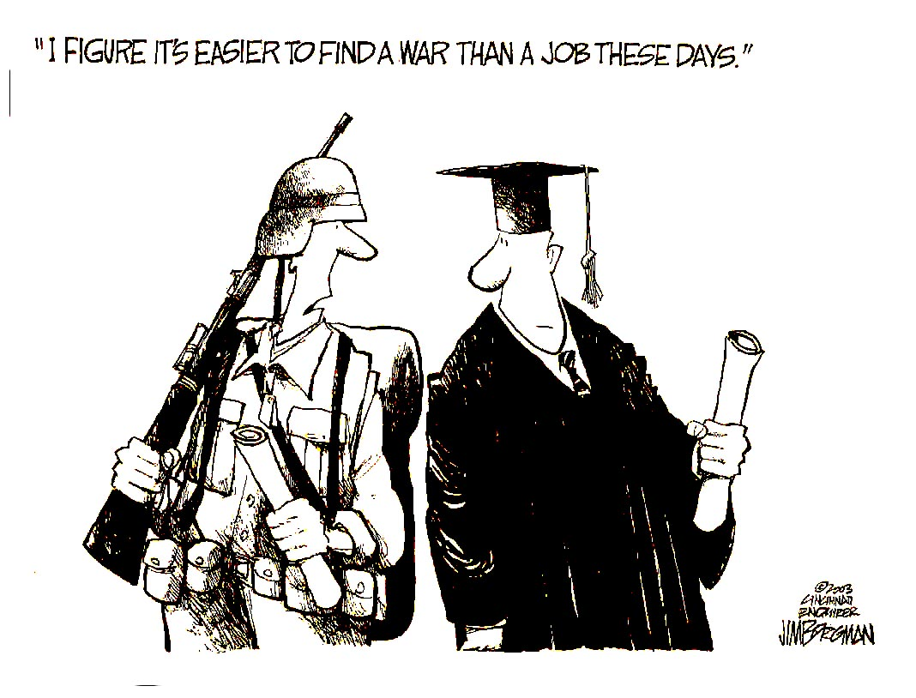

Works Cited
Bender, Bryan. "Down Economy Boosts Military." Boston.com, 1 Mar. 2009. Web. 12 Sept. 2012. <http://www.boston.com/news/nation/washington/articles/2009/03/01/down_economy_boosts_military/?page=full>.
Borgman, Jim. Borgman Political Caroon. Digital image. N.p., 21 Nov. 2008. Web. 12 Sept. 2012. <http://paulocoelhoblog.com/images/image-of-the-day/Borgman.jpg>.
Gongloff, Mark. "U.S. Unemployment Rate Rises to 5.8% in February." CNNMoney. Cable News Network, 7 Mar. 2003. Web. 12 Sept. 2012. <http://money.cnn.com/2003/03/07/news/economy/unemployment/index.htm>.
"Jim Borgman - Political Cartoonist." Cincinnati.com, 27 Mar. 2007. Web. 12 Sept. 2012. <http://borgman.cincinnati.com/default.aspx>.
"Support Army Recruiting." Support Army Recruiting. US Army Recruiting Command, 19 Dec. 2011. Web. 12 Sept. 2012. <http://www.usarec.army.mil/hq/apa/goals.htm>.

